Tel: (+232)78-522-838
Email: info@tourism.gov.sl
Ministry of Tourism and Cultural Affairs
28B Kingharman Road
Freetown
Sierra Leone


GOVERNMENT OF SIERRA LEONE

MINISTRY OF TOURISM AND CULTURAL AFFAIRS

CALL FOR EXPRESSIONS OF INTERST FOR THE LEASING AND OPERATING OF THE VIEWING PLATFORM AND ANCILLARY FACILITIES/SERVICES AT LEICESTER PEAK
DATE OF ISSUE: 26th NOVEMBER, 2025

FIRM SELECTION

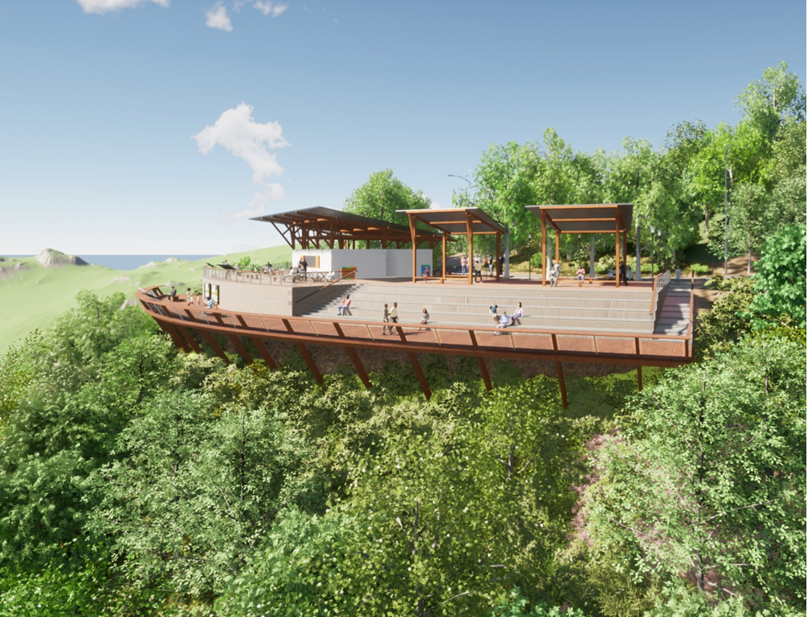

LETTER OF INVITATION
Call for Expressions of Interest
Date: 26th November, 2025
Dear Sir/Madam
RE: Tender NO: MTCA-EOI-2-2025: TO LEASE THE VIEWING PLATFORM AND ITS ANCILLARY FACILITIES/SERVICES AT LEICESTER PEAK
The Government of Sierra Leone (GOSL), through the Ministry of Tourism and Cultural Affairs (MTCA) and the Ministry of Finance, invites eligible and qualified Applicants to manage its state-of-the-art- tourism facilities at Leicester Peak. The facility consists of a 564m Viewing Platform that provides a 270° panoramic view of the green forest cover of the Western Area National Park, coastline, the city and its landmarks, the site of the 2017 landslide, and other scenic views.
GOSL, through the Ministry of Finance and the Ministry of Tourism and Cultural Affairs, wishes to invite interested and eligible candidates to submit Expressions of Interest (EOIs) for managing the already completed tourism structures at Leicester Peak. A short list of Applicants will be invited to submit formal proposals for the management of the facilities.
It is the intention of the Government of Sierra Leone that the facilities will be managed subject to a Lease Agreement with the successful Applicant.
ITEM | TENDER REF. NO. | TENDER NAME | CLOSING DATE
1. | GOSL/MTCA-EOI-2-2025 | Leasing of tourist facilities at Leicester peak | 10th December, 2025

Communication with regards to the EOI must be in writing and sent to the following email: kamarammartha123@gmail.com and copy sleconomicdiversification@gmail.com and osmantommy@sledp.info and/or send hard copies to the Ministry’s Head Office at 28B Kingharman Road, Freetown.
All clarifications and/or amendments will be published in MTCA website (tourism.gov.sl.) and Tenderers are required to check for any addendums or amendments in the course of the bidding period prior to the closing date indicated above.
MTCA will conduct an information session on the tourism facilities at Leicester Peak. Additionally, visit to the facilities will be facilitated by the Ministry for those applicants that meet the initial threshold specified in this EOI.
Submission of EOI
The completed EOIs in plain sealed envelope marked with tender reference number and tender name, shall be deposited into the EOI Box located at the Head Office of MTCA located at 28B Kingharman Road, Freetown, on or before 10th December, 2025.
1.0 BACKGROUND
The Government of Sierra Leone in its Medium-Term National Development Plan 2019-2023, made a commitment to diversify the country’s economy away from the mining sector. To this end, tourism was identified as one of the key growth sectors that will underpin the diversification agenda of Government.
With support from World Bank, the Government of Sierra Leone, through the Ministry of Tourism and Cultural Affairs, has designed and implemented several tourism development activities under its Sierra Leone Economic Diversification Project. A key tangible output of the Sierra Leone Economic Diversification Project is the development of tourism sites in three locations in Western Region of Sierra Leone. One of the most outstanding tourism sites under this project is the Leicester Peak Viewing Platform and its ancillary facilities/services.
Strategically located on top of a hill in Freetown, the Leicester Peak tourism facility is elevated at 564m above sea level, giving visitors a 270° panoramic view of the city and its iconic landmarks; the coastline and its pristine beaches; beautiful, green-covered mountains, and other breathtaking scenic views. The site is part of the Western Area Peninsula National Park and provides a recreational and educational attraction whilst offering a new and outstanding experience for residents and visitors to Freetown. The facility includes a green-parking area with 36 parking stalls (450sqm).
The Government of Sierra Leone, through the Ministry of Tourism and Cultural Affairs, wishes to invite prospective operators to manage the tourist facilities at Leicester Peak.
1.1 DETAILED DESCRIPTION OF THE SITE
The Leicester Peak tourism site was developed mainly to provide visitors with the thrilling experience of viewing the city of Freetown with its iconic landmarks and other famous locations, including the Western Area Peninsula Mountains and the site of the 2017 landslide from a 564m elevation. Moreover, as seen below, the site is equipped with other facilities to further enhance the overall visitor experience. The successful applicant will manage a world class tourism facility that offers recreation, education and entertainment experiences to its visitors. Below is a detailed description of the various tourism facilities at the Leicester Peak tourism site.
Access Road
The SLEDP has significantly improved the access road that leads to the Leicester Peak tourism facilities. To enhance swift and easy access to the facility, the project has improved the road with drainages and full asphalting of its entire 2.5km length. The road is also equipped with solar street lighting system.
Visitors are now guaranteed a smooth and safe drive along the road leading to the Leicester Peak tourism site.

Car Park
The facility is equipped with 2 parking areas for visitors covering an area of 450sqm and providing 36 parking stalls including designated parking spots for people with disabilities.
Viewing Platform
The Viewing Platform is 1,700sqm wooden structure that has 3 separate viewing areas (East, West and Central platforms), where visitors can have a 270° panoramic view of the city and its iconic landmarks; the coastline and its pristine beaches, the Western Area Peninsula Mountains and the site of the 2017 landslide disaster.
The Viewing Platform is also equipped with a Cafeteria and reception point (to be fitted out by the investor) for guided tours (closed shaded structure of 280sqm), including 4 visitors’ toilets of which two are for people with disabilities. At the upper level of the deck, there is a resting panoramic terrace/event space of 1,200sqm equipped with shaded seating areas, viewpoint, selfie point, and visitors’ and staff facilities.
The Platform also has a small educational area on the lower level which is an area of approximately 150sqm; and an area designated for vendors to sell handcrafts/gift items.
The Platform is designed to accommodate visitors who have physical disabilities.
The matrix below presents a summary of facilities provided at the Leicester Peak Site:
Type of facility | Site | Location | Site Status
- Viewing Platform  - Cafeteria  - Visitor Center  - Vendor Canopies  - Education Space  - Scenic walking trails  - Car Park-36 parking stalls (450sqm).  - Wifi for visitors | Leicester Peak | Leicester community off-American Embassy | 90% Complete

2.0 GENERAL CONDITIONS FOR THE MANAGEMENT OF THE SITE
It is the intention of the GOSL to enter a Lease Agreement with a private operator with the needed additional investment capital, and the requisite competence to effectively operate, manage and maintain the tourism facilities at the Leicester Peak tourist site in a manner that will improve the touristic posture of the country and generate significant revenue for the returns.
The selected operator will uphold the following conditions for the management of the site:
- The operator will be responsible for the additional fit-out of the facilities, including but not limited to any required furniture, fittings and equipment including kitchen equipment.
- The operator will be responsible for the payment of annual rent to the Ministry of Tourism and Cultural Affairs and fulfill all tax and licenses obligations associated with managing such a facility.
- The operator will procure additional goods and services to enhance the effective management of the Leicester Peak facility;
- The operator will have the primary responsibility for marketing the facilities to local and international markets;
- The operator will be responsible for recruiting the requisite staff compliment in compliance with the labour laws and policies of Sierra Leone (priority should be given to local candidates with requisite skills, qualification and experience);
- In line with sustainable and safe tourism practice, the operator will be responsible for ensuring that all environmental and safety standards are strictly adhered to;
- The operator will be responsible for maintaining high environmental and safety standards at all the facilities within the Leicester Peak site (special attention should be paid to conservation, reforestation and biodiversity protection). Specifically, the investor will put mechanisms in place to protect visitors using the platform to avoid injury to visitors;
- The operator will be responsible for repairs and maintenance of the facility including replacement of operational items during the period of the Lease Agreement;
- The operator will provide regular inventory and update on the state of the facility to the Ministry of Tourism and Cultural Affairs (the exact timeframe will be indicated in the Lease Agreement); and
- The operator will adhere to all provisions and/or obligations outlined in the Lease Agreement.
3.0 REQUIREMENT FOR COMPLETION OF EOI
3.1 Mandatory Documents
NO. | REQUIREMENT
1 | Legal Status - State whether the Applicant is a Limited Liability or Sole Proprietorship or Partnership
2. | Valid tax compliance certificate from the National Revenue Authority
3. | Certificate of Incorporation or Business Registration
4. | Identification document (National Identity Card or Passport) of the CEO or Head of the entity sending in the proposal
5. | Duly filled, signed and stamped Self- Declaration letter that the applicant or his/her firm has not been debarred from participating in Public Procurement
6. | Duly filled, signed and stamped Self- Declaration that the investor or his/her firm will not engage in any corrupt or fraudulent practice
7. | Company Profile of the firm indicating the contact details including physical address, telephone number, email and contact person on behalf of the applicant

3.2 Capability to Manage the Site
NO. | EXPECTED INFORMATION | REQUIRED FORMAT
1 | Firm Corporate History | Provide a short narrative of origin, development, mission and values of Applicant
2 | Capability to manage the site | Provide a statement of the Applicant’s capability and experience relevant to the management of the site.
3 | Qualifications, technical expertise and experience of the Applicant’s key personnel who will be directly involved in the management of the chosen site | Use simple format to present the CVs for key personnel.

3.3 Proposed Operational and Management Plan
The Applicant should provide a brief narrative of their proposed operational and management plan for the site including their intended fit-out and capital investment plan the narrative should indicate innovative business methods that will employed to guarantee visitor satisfaction, revenue generation and sustainability of the facilities.
3.4 Financial Soundness
The Applicant should demonstrate that the firm has access to or has available liquid assets, unencumbered real assets, lines of credit, and other financial means sufficient to meet the requirement of procuring additional goods and services for the Leicester Peak tourism site.
In addition, a copy of the Applicant’s signed and stamped Audited financial statements, balance sheets and computed working capital for the most recent three (3) years along with any other relevant financial information should be submitted demonstrating the soundness of the Applicant’s financial position and capacity to undertake the investment required to meet the terms of the Lease Agreement.

4.0 EVALUATION CRITERIA
Expression of Interest will be evaluated on their responsiveness to the above requirements based on the following criteria:
NO | CRITERIA | MAXIMUM SCORE/POINTS
1 | Mandatory documents* | Must be submitted
2 | Capability to Manage the Site | 30
3 | Proposed Operational, Management and Capital Investment Plan | 40
4 | Evidence of financial soundness | 30
 | TOTAL | 100

For additional information, Applicants should contact Mrs. Martha B. Kamara, the Assistant Director of Procurement, Ministry of Tourism and Cultural Affairs on +232 78 522 838 or via email kamarammartha123@gmail.com and copy sleconomicdiversification@gmail.com and osmantommy@sledp.info

