Tel: (+232)76-522-838
Email: info@tourism.gov.sl
Ministry of Tourism and Cultural Affairs
28B Kingharman Road
Freetown
Sierra Leone


GOVERNMENT OF SIERRA LEONE

MINISTRY OF TOURISM AND CULTURAL AFFAIRS

EXPRESSION OF INTEREST FOR LEASING AND OPERATING OF SURF CLUB, MARKET SHEDS AND OTHER TOURISM FACILITIES AT BUREH BEACH
DATE OF ISSUE: 26th NOVEMBER, 2025

FIRM SELECTION

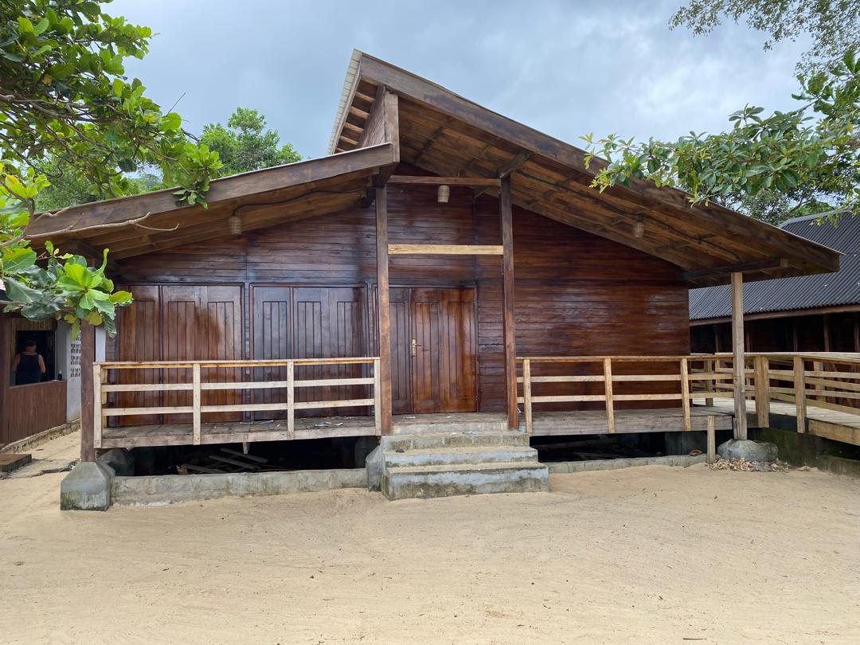

1.0 LETTER OF INVITATION
Date: 26th November, 2025
Dear Sir/Madam
RE: Tender NO: GOSL/MTCA -EOI-3-2025: TO LEASE THE SURF CLUB, MARKET SHEDS AND OTHER TOURISM FACILITIES AT BUREH BEACK
The Government of Sierra Leone, through the Ministry of Tourism and Cultural Affairs (MTCA) and the Ministry of Finance, invites eligible and qualified bidders to lease its high value tourism facilities at Bureh Beach which comprises Surf Club, Market Sheds, and other ancillary facilities and services.
The Government of Sierra Leone, through the Ministry of Finance and the Ministry of Tourism and Cultural Affairs, wishes to invite interested and eligible candidates to submit Expressions of Interest (EOIs) for leasing operating the tourism structures at Bureh Beach. A short list of Applicants will be invited to submit formal proposals for leasing of the facilities.

It is the intention of the Government of Sierra Leone that the facilities will be managed subject to a Lease Agreement with the successful Applicant.
ITEM | TENDER REF. NO. | TENDER NAME | CLOSING DATE
1. | GOSL/MTCA/EOI-1-2025 | Leasing of tourist facilities at Bureh Beach | 10th December 2025

Communication with regards to the EOI must be in writing and sent to the following email: kamarammartha123@gmail.com and copy sleconomicdiversification@gmail.com and osmantommy@sledp.info and/or send hard copies to the Ministry’s Head Office at 28B Kingharman Road, Freetown.
All clarifications and/or amendments will be published in MTCA website (tourism.gov.sl.) and Tenderers are required to check for any addendums or amendments in the course of the bidding period prior to the closing date indicated above.
MTCA will conduct an information session on the Bureh Beach tourism facilities. Additionally, visit to the facilities will be facilitated by the Ministry for those applicants that meet the initial threshold specified in this EOI.
Submission of EOI
The completed EOIs in plain sealed envelope marked with tender reference number and tender name, shall be deposited into the EOI Box located at the Head Office of MTCA located at 28B Kingharman Road, Freetown, on or before 10th December, 2025.

1.0 Background
The Government of Sierra Leone in its Medium-Term National Development Plan 2019-2023, made a commitment to diversify the country’s economy away from the mining sector. To this end, tourism was identified as one of the key growth sectors that will underpin the diversification agenda of Government.
With support from the World Bank, the Government of Sierra Leone, through the Ministry of Tourism and Cultural Affairs, has designed and implemented several tourism development activities under the Sierra Leone Economic Diversification Project. A key tangible output of the project is the development of tourism sites in three locations in Western Area of Sierra Leone. One of the most outstanding tourism sites under this project is the Surf Club and other facilities including market sheds, Community Garden and a car park with 30 car stalls.
Located along the Freetown Peninsula, Bureh Beach is a popular surfing spot and general relaxation destination. The sandy shore is wide and clean and the scene is charming. The landscape is visually attractive with yellow sand interspersed with black volcanic rocky outcrops that provide a natural divider of the beach into two separate stretches.
With the addition of the aforementioned facilities to this already naturally crafted beauty, Bureh Beach is projected to guarantee 14,919 guests annually. The estimated returns on investments for destination has made this facility a highly competitive tourism asset.
The Government of Sierra Leone, through the Ministry of Tourism and Cultural Affairs, wishes to invite prospective investors to lease this high value tourism facility situated at Bureh Beach with a view to enhancing visitor experience. The prospective investor will pay rent to the Government, a portion of which will be allocated to the community.
1.1 Detailed Description of the Site
Where selected, the Investor will be leasing a high-quality tourism infrastructure with all composite facilities that will enhance visitor experience. Below is the detailed description of the various facilities provided at the Bureh Beach site.
Access Road to the facilities
Access to the site is through a 550m road which was hitherto unpaved and without a functioning drainage system. Under the project, the access road has been upgraded with paved concrete and well-constructed drainage system. The road is also equipped with a spacious pedestrian sidewalk, a ticket booth and solar street lighting system.
Car Park
The new Bureh Beach tourism facility will be completed with a beautiful landscaping work and a vast ‘’green parking’’ facility with 10 parking bays including parking spaces for people with disabilities.
Surf Club
As indicated above, Bureh Beach is a popular destination for surfing and other water sports. However, over the past years, surfing facilities on the beach have become deplorable at best. The SLEDP project has now erected a new Surf Club on the Bureh Beach for public use. The approximately 10sq m Surf shelter is equipped with office space, a store for the safe keeping of surfboards, a changing room, and a lobby area. The Surf Club is located on the North Side of the beach close to the ocean. The structure is protected from the direct waves of the sea by a high-rise reinforced concrete wall.
Market Sheds
The site has 3 market sheds that can be used as handicraft/gift shop. The sheds are strategically located on the beachfront to ensure that visitors enjoy the natural ambience of the pristine beach whilst patronizing with vendors selling handmade local products.
Boardwalk
The facility has a landscaping of a beach boardwalk that stretches about 500m connecting all the major facilities from the Toilet block to the Surf Club, to the Market Sheds right through to the Jetty on the south side of the beach. The boardwalk is equipped with low-intensity led lights every 3m.
Toilet Block
The site is equipped with modern toilet blocks on both the North and the South sides of the beach. Each toilet block is approximately 130sqm and has 2 showers and 4 composting toilets including facilities for persons with disabilities and infants. The project also provided water towers for each toilet block. The toilet blocks, like the other structures on the site, are roofed with polyethylene-aluminum roof which is appropriate for the close proximity to the sea.
Community Garden
The project made provision for a community garden which is located close to the entrance of the facility. The garden is on an area of land of approximately 400sqm. The garden has a watering system and a garden shed to house gardening tools, and space for the gardeners to change and rest during the day. The garden is expected to provide fruits and vegetables for the local market as well as for visitors.
The matrix below presents a summary of facilities provided at the Bureh Beach Site:

Type of facility | Site | Location | Site Status
- Surf Club (An office space, changing room, store for surfboard)  - 3 Market Sheds (Handicrafts/gift shops)  - Community Garden  - Car Park(10 Parking Bays  - Toilet Block  - 500m Boardwalk | Bureh Beach | Bureh Beach | 90% Complete

2.0 GENERAL CONDITIONS FOR THE LEASING OF THE SITE
As indicated earlier, the objective is to find a competent private sector partner to lease, operate and effectively manage the Bureh Beach facilities with a view to improving the touristic posture of the community and the country as a whole.
Where selected, the investor will uphold a range of conditions for the leasing of the site including:
- The investor will be responsible for the payment of annual rent to the Ministry of Tourism and Cultural Affairs and addition, fulfill all tax and licenses obligations associated with running such facilities;
- Procure additional goods and services to enhance the effective operation and management of the tourism facilities at Bureh Beach;
- The investor will ensure that environmental protection standards are maintained on the facility.
- The investor will bear the primary responsibility of marketing the Bureh Beach tourism facilities to local and international tourists;
- The investor will ensure that all the facilities are fully functional at all times and open to customers/visitors;
- The investor will be responsible for recruiting requisite staff compliment in compliance with labour laws and policies of Sierra Leone (Priority should be given to local candidates with requisite skills, qualification and experience);
- The operator will provide regular inventory and update on the state of the facility to the Ministry of Tourism and cultural affairs (the exact timeframe is indicated in the lease agreement); and
- Adhere to all provisions and/or obligations outlined in the Lease Agreement that she/he will sign, if selected.

3.0 REQUIREMENT FOR COMPLETION OF EOI

3.1 Mandatory Documents
NO. | REQUIREMENT
1 | Legal Status - State whether the Applicant is a Limited Liability or Sole Proprietorship or Partnership
2. | Valid tax compliance certificate from the National Revenue Authority
3. | Certificate of Incorporation or Business Registration
4. | Identification document (National Identity Card or Passport) of the CEO or Head of the entity sending in the proposal
5. | Duly filled, signed and stamped Self- Declaration letter that the applicant or his/her firm has not been debarred from participating in Public Procurement
6. | Duly filled, signed and stamped Self- Declaration that the investor or his/her firm will not engage in any corrupt or fraudulent practice
7. | Company Profile of the firm indicating the contact details including physical address, telephone number, email and contact person on behalf of the applicant
3.2 Capability to Manage the Site
NO. | EXPECTED INFORMATION | REQUIRED FORMAT
1 | Firm Corporate History | Provide a short narrative of origin, development, mission and values of Applicant
2 | Capability to manage the site | Provide a statement of the Applicant’s capability and experience relevant to the management of the site.
3 | Qualifications, technical expertise and experience of the Applicant’s key personnel who will be directly involved in the management of the chosen site. | Use simple format to present the CVs for key personnel.

3.3 Proposed Operational and Management Plan
Additionally, investors will be expected to provide a brief narrative of their proposed operational and management plan for the selected site. The narrative should indicate innovative business methods that will be employed to guarantee visitor satisfaction, revenue generation and sustainability of the facilities.
3.4 Financial Soundness
The bidder should demonstrate that the firm has access to or has available, liquid assets, unencumbered real assets, lines of credit, and other financial means sufficient to meet the requirement of procuring additional goods and services for the selected site.
In addition to the aforementioned, a signed and stamped Audited accounts, balance sheets and computed working capital for the most recent three (3) years should be submitted and must demonstrate the soundness of the Applicant’s financial position.
4.0 EVALUATION CRITERIA
Expression of Interest will be evaluated on their responsiveness to the above requirements based on the following criteria:
NO | CRITERIA | MAXIMUM SCORE/POINTS
1 | Mandatory documents* | Must be submitted
2 | Corporate documentation | 30
3 | Proposed Operational and Management Plan | 40
4 | Evidence of financial soundness | 30
 | TOTAL | 100

For additional information, Applicants should contact Mrs. Martha B. Kamara, the Assistant Director of Procurement, Ministry of Tourism and Cultural Affairs on +232 78 522 838 or via email kamarammartha123@gmail.com and copy sleconomicdiversification@gmail.com and osmantommy@sledp.info

